**VDI** User desktops runs on vm in datacenter!

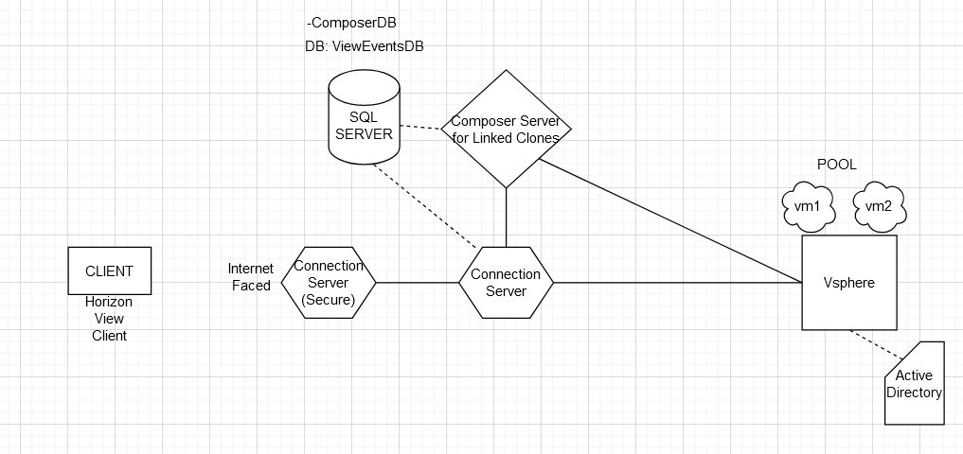

User computer-Connection Server-Vsphere

Prereqs:

* Active Directory
* Vsphere environment
* Member server to active directory
* Connection server has static IP and resolvable hostname on AD
* Domain administrator should have rights on vsphere

Products

<https://my.vmware.com/web/vmware/downloads/details?downloadGroup=VIEW-7103-STD&productId=924>

Connection Server

Horizon 7.10.3 View Connection Server (64-bit)

Install with domain administrator rights

WEBUI login Connection_Server_IP/admin

[administrator@domain.name](mailto:administrator@domain.name)

MS-SQL server

DB: ViewEventsDB

User: db-user with full rights on ViewEventsDB

Allow inbound connections

Virtual Machine

* Domain member
* On vsphere infrastructure
* **Horizon view agent** installed on it

User Computer:

Installed **horizon view client (if no horizon view client, user can use html5 via browser, if pool supports)**

Windows, Mac, linux, ios, android

**Connect to connection server via hostname on browser!**

**Then download link**

*Horizon View Manual Desktop Pools*

1. Deploy VMs in vsphere
2. Create pools in view
3. Link VMs to pool
4. Entitle user/groups to use pools

*Horizon View Automatic Desktop Pools*

Spare vms are waiting for connection, when new request comes, it provision new VM from template (provisioning on demand)

Entitle which user will use this pool

*Linked Clone*

Composer server: Domain member server and composer software is installed (with SQL-ComposerDB) and add it to vcenter

Create VMs, power off vm and take snapshot and compose/recompose (automated pool, choose linked clone)

*RDS Services (Microsoft) and Horizon*

Create Application Farm on Horizon Administrator panel and register connection server

OR

Create RDS Desktop Pool

*Persona Management*

User logins to floating pool (everytime different vm) and his profile is shared within vms

Persona policy template is used

*Horizon View Security server*

Installation is same as connection server but with security option

Two interface: internet faced, intranet faced

Client>Security Server (non-domain member)>Connection Server>Pools